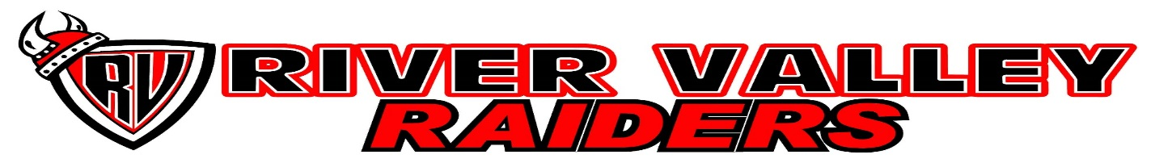

Clothing Order
Item Price Color(Please circle) Size(adult S, M, L, XL,,Youth S,M,L,Xl)
Hoodie $30 Black or Red ______________________
Track Jacket $60 Black Only ______________________
Track Pants $35 Black Only ______________________
Sweat Pants $25 Black or Red _______________________
Ball Hat $15 Black or Red _______________________
Toque $15 Black or Red ________________________

Additional Costs:
Personalization(name, sport, etc..) $5 per location
Note – We will be taking order in February for hoodies with the signed class of 2018
Student Name:____________________________ Phone/Email:_________________________________
Personalization:________________________________________________________________________
Order Total: ____________________________________________
Payment Method: Cash_________ Cheque(put students name on the memo line): ______________
All orders must be handed into the school office by December 1st(must have order form & payment)
Orders will be delivered to the School the last week of school before the Christmas Break

McCluskey Brothers Inc 654-2218

